
Submitted by : Spogmai Jan
Roll no : 2430 -0081
Submitted to : sir nouman asim

Computer networks lab 09

TASK 01:
Design a network using two switches with two LAN which have at least 2PC’s. Connect these LAN’s with two Routers Router 1 Area is 1 and Router 2 area is 3 . Configure the Network by using OSPF. Get the reply (msg broadcasting) from PC0 of One LAN to others LAN any PC’s.

Router 1:
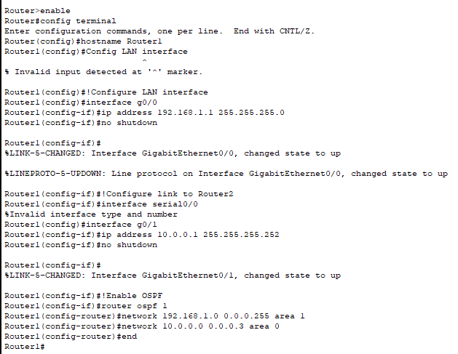

Router 2:
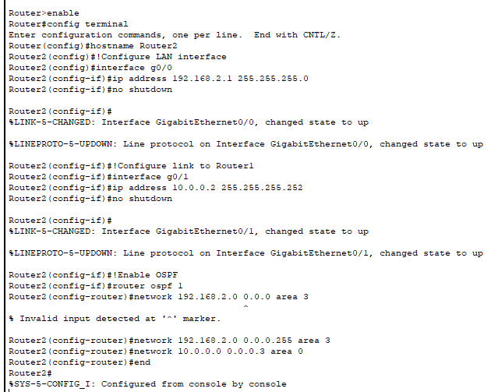
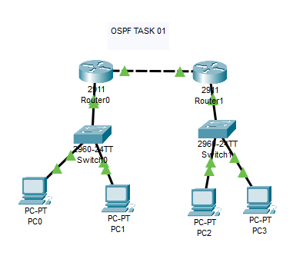
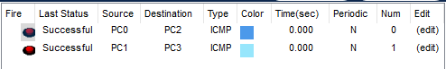

TASK 02: Create a network in which you have three Routers with 3 switches. Switches are connected at least 2PC’s as S1 with LAN A , Area 1, S2 with LAN B ,Area 0 and S3 , LAN C with Area 2. It’s should be done by properly creating OSPF. Enable LAN communication by allowing message broadcasting between the different LANs across the switches.

Router 1:
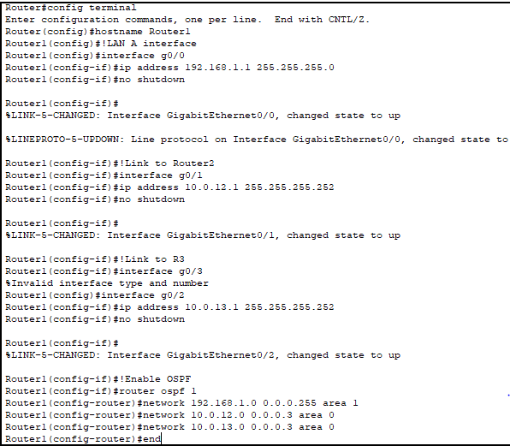
Router 2:
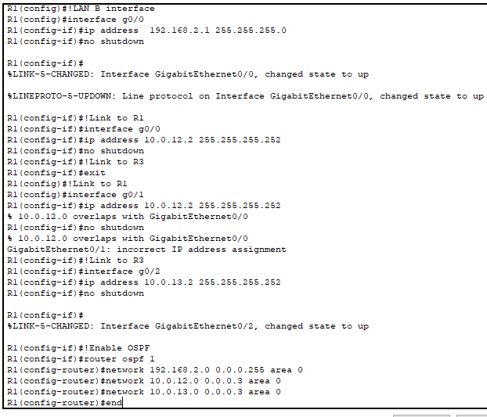

Router 3:
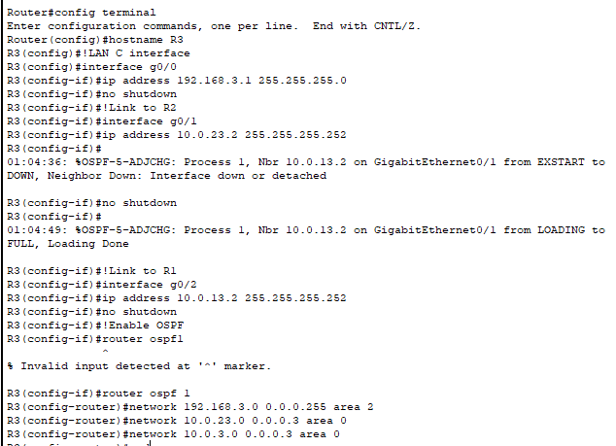
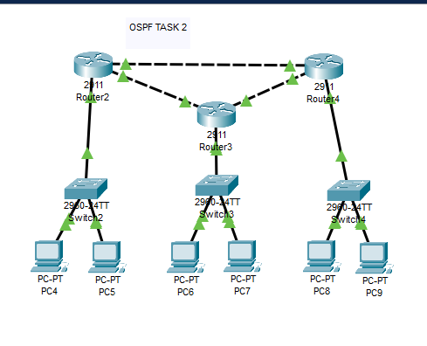
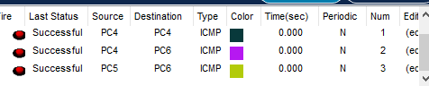

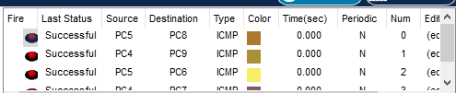
TASK 03:
Design a network using 3 routers and switches, Router 1 have Switch 1 and Switch 2 w.r.t. LAN A and LAN B and Router 2 have Switch 1 with LAN C and Router 3 have , Switch 1 and switch 2 w.r.t. LAN D and LAN E . Configure the Network by using OSPF.

Router 1:
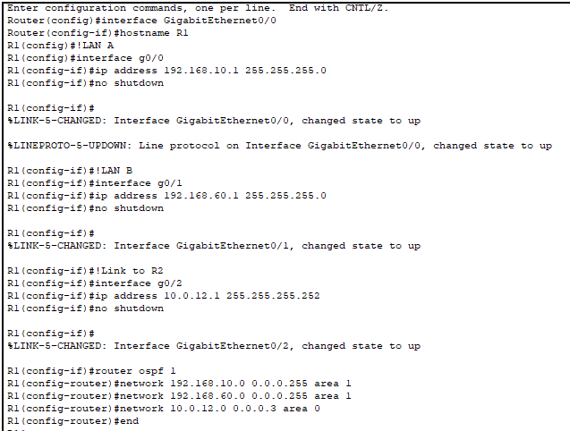
Router 2:
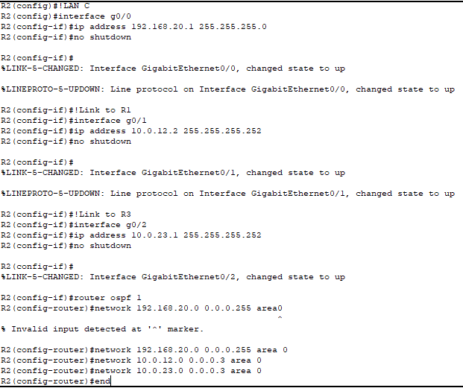
Router 3:



